 | 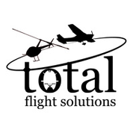 | 450 Airport Road, Suite 200  Louisburg, NC 27549  (919) 497-5511

Training Course Outline
  - FAA Certificate # 12LS941L

Part 141

Airplane Private Pilot

Single-Engine Land

  - Tim Grant, Director of Education

Table of Contents
Table of Contents 2
Log Revisions 3
List of Effective Pages 4
Enrollment Procedures 5
A: Outline A-1
A-1: Objective A-1
A-2: Airport Listings A-1
A-3: Ground Training Facilities A-2
A-4: Training Aids A-3
A-5: Facility Description A-4
Main Operations Location (KLHZ) A-4
Satellite Training Location (KSOP) A-4
A-5: Aircraft A-4
A-7: Chief Instructor Qualifications A-4
A-8: Assistant Chief Instructor Qualifications A-4
A-9: Flight Instructor Qualifications A-5
C: Airplane Private Pilot Single-Engine Land Certificate C-1
C-1: Airplane Private Pilot Single-Engine Land C-1
Airplane Private Pilot Single-Engine Land Certificate Requirements C-1
C-2: Student Information & Syllabus C-1
Enrollment Prerequisites C-1
Graduation Requirements C-1
Stage Checks C-2
Previous Training Credit C-2
Ground Training Syllabus C-2
Flight Training Syllabus C-3
Stage Checks C-3
Flight Lesson Sequence C-3
Student Pilot Preparation C-4
Repeating Lessons C-4
D: Record Keeping D-1
D-1: Student Record Keeping D-1
Student Information D-1
Ground School Training D-1
Flight School Training D-1
D-2: Forms & Certificates D-1

Log Revisions
Revision | Date | Page | Initials
Original | 09/01/2017 | All | MDM
1 | 03/21/2018 | All | MDM
2 | 12/01/2019 | All | RBM
3 | 03/01/2020 | All | RBM
4 | 07/01/2020 | All | RBM
5 | 06/06/2021 | All | MDC
6 | 06/29/2021 | GM-2-6, GM-A-4, GM-C-IR, GM-C-CP, GM-D | TDG
7 | 12/16/2021 | GM-3-4, GM-A-4 | TDG
8 | 6/28/2022 | GM-3-4 GM-A-2-5 | TDG
9 | 7/15/2022 | GM-3-4 GM-A-2-3 | TDG
10 | 1/30/2023 | GM-3-4, GM-A-2-4, GM-B-6-7 | TDG
11 | 7/16/2023 | All | TDG

List of Effective Pages
  Page No | Revision | Date
  1 | 11 | 7/16/2023
  2 | 11 | 7/16/2023
  3 | 11 | 7/16/2023
  4 | 11 | 7/16/2023
  5 | 11 | 7/16/2023
  Section A
  1 | 11 | 7/16/2023
  2 | 11 | 7/16/2023
  3 | 11 | 7/16/2023
  4 | 11 | 7/16/2023
  5 | 11 | 7/16/2023
  Page No | Revision | Date
  Section C
  1 | 11 | 7/16/2023
  2 | 11 | 7/16/2023
  3 | 11 | 7/16/2023
  4 | 11 | 7/16/2023
  Section D
  1 | 11 | 7/16/2023
  2 | 11 | 7/16/2023
  3 | 11 | 7/16/2023
  4 | 11 | 7/16/2023
  5 | 11 | 7/16/2023
  6 | 11 | 7/16/2023
  7 | 11 | 7/16/2023
  8 | 11 | 7/16/2023
  9 | 11 | 7/16/2023

Enrollment Procedures
Each student enrolling in an approved training course will receive the following:
- A certificate of enrollment containing the name of the course in which the student is enrolled and the date of enrollment (see D-2).
- A copy of the Training Course Outline (TCO); which includes covering the use of the facilities, operation of the school’s aircraft and the applicable syllabus.
- A copy of the Safety Procedures and Practices.
- Enrolling in the Airplane Private Pilot Single-Engine Land course
  - The student will utilize the Gleim Private Pilot Kit, Gleim Ground School Private Pilot (Part 141) course.

A: Outline

A-1: Objective
It is the purpose of this document to prepare individuals for the FAA Knowledge and Practical Tests. This document meets all the curriculum requirements for Certification contained in Appendix B of 14 CFR Part 141.

A-2: Airport Listings
- Triangle North Executive Airport (KLHZ) is the Main Operations Location.
- Moore County Airport (KSOP) is a Satellite Training Location.

A-3: Ground Training Facilities
- Main Operations Location: Located at the Triangle North Executive Airport (KLHZ), the ground training facilities are housed in five (5) rooms, described below. The rooms are located on the 2nd floor hangar building.
  - Training room 1: Dimensions are 8' 6” x 10' with one entry/exit door. The room is equipped with a desk, 2 chairs and will accommodate a maximum of 2 occupants. A 36" x 34" dry-erase whiteboard is permanent equipment.
  - Training room 2: Dimensions are 8' x 10' with one entry/exit door. The room is equipped with a desk, 3 chairs and will accommodate a maximum of 3 occupants. A 24” x 33” dry-erase whiteboard is permanent equipment. Additional training aids consist of a flight instrument poster, aircraft systems poster, principles of flight poster, and miniature airplane.
  - Training room 3: Dimensions are 8’x 10’ with one entry/exit door. The room is equipped with a desk, 2 chairs and will accommodate a maximum of 2 occupants. A 54” x 33” dry-erase whiteboard is permanent equipment. Additional training aids consist of airport markings and signage posters, principles of flight poster, flight instruments poster, Cessna 172 cockpit display poster and miniature airplane.
  - The Flight Planning Room is located next to the reception area at the entrance of the hallway. Dimensions are 14’ x 14’ with one entry/exit door. The room is equipped with a large table, chairs, computer with internet connection, wifi and wireless printer, landline telephone, reliable cellular reception and will accommodate approximately 5 occupants. A 20” x 33” dry-erase whiteboard is permanent equipment. Additional training aids consist of sectional charts affixed to the planning table, VFR sectional poster, compass deviation tables for the training aircraft, automated surface weather observing systems poster and a Cessna 172 cockpit display poster.
  - Training Room 4 is located halfway down the main hallway. Dimensions are 15’9” x 14’7” with one entry/exit door. The room is equipped with a Redbird BATD, a desk, 3 chairs and will accommodate a maximum of approximately 10 occupants. A 35” x 22” dry-erase board is permanent equipment. Additional training aids consist of a VFR sectional poster and a Cessna 172 cockpit display.
  - The Main Classroom is located towards the rear spaces. Dimensions are 23’ x 28’ with 2 entry/exit doors. The room is equipped with an instructor’s desk, 13 movable desks, 30 chairs, overhead media projector with HDMI connection and will accommodate approximately 30 occupants. A 15’ x 3’ dry-erase whiteboard is permanent equipment.
  - The Reception Area is located towards the front entrance. Dimensions are 17’ x 25’ with one entry/exit door. The room is equipped with Dispatch and Maintenance Repair documents, a large table and chairs.

- Satellite Training Location: Located at the Moore County Airport (KSOP), the ground training facilities are housed in three (3) rooms, described below. The room is located on the 1st floor of the main building.
  - Training room : Dimensions are 15’ x 10' with one entry/exit door. The room is equipped with a desk, a conference table, 7 chairs and will accommodate a maximum of 7 occupants. A 36" x 34" dry-erase whiteboard is permanent equipment.
  - The Flight Planning Room is located next to the reception area. Dimensions are 11’ x 12’ with two entry/exit doors. The room is equipped with a desk, 2 chairs, computer with internet connection, connection to wireless printer, reliable cellular reception and will accommodate approximately 2 occupants.
  - The Reception Area is located towards the front entrance. Dimensions are 12’ x 10’ with one entry/exit door. The room is equipped with Dispatch and Maintenance Repair documents, supplies of the aircraft such as oil and window cleaner, computer with internet connection, wireless printer, a desk, 2 chairs and will accommodate 2 occupants.

All training rooms meet or exceed all local building, health and sanitation codes. Restrooms are provided in the building. Each room is well lit and provided with ventilation and air conditioning. The rooms are designed and located so that students will not be distracted by instruction conducted in other rooms or by airport operations.

A-4: Training Aids
The following audiovisual and training aids are available:
- Computers with Internet access
- Whiteboards
- Publications and reference material
- Overhead media projector
- Sectional Posters
- Aircraft cockpit, systems and principles of flight posters
- Miniature aircraft

A-5: Facility Description
The ground training facilities are located at the Triangle North Executive Airport (KLHZ) and Moore County Airport (KSOP). The facilities are used exclusively by students and itinerant pilots.

Main Operations Location (KLHZ)
- The facility is equipped with 3 pilot briefing rooms outside of the main reception area.
- The Flight Planning Room is located next to the reception area at the entrance of the hallway. The room is equipped with a large table, chairs, computer with internet connection, Wi-Fi and wireless printer, landline telephone and reliable cellular reception for obtaining weather and filing flight plans.
- Pre and post flight lesson briefings will be conducted in Training Rooms 1, 2, 3 as listed in Sect. A-3.

Satellite Training Location (KSOP)
- The facility is equipped with a main reception/ dispatch desk with the flight planning room attached.
- The Flight Planning Room is equipped with a desk , chairs, computer with internet connection, Wi-Fi and reliable cellular reception for obtaining weather and filing flight plans.
- The training room is located away from the reception area down the back hallway, next to the last door on the right. The room is equipped with a desk, a conference table, chairs and whiteboard.
- Pre and post flight briefings will be conducted in the training room. Section A-3

A-6: Aircraft
This course of training will utilize (5) Cessna 172s. These aircraft will meet the requirements of 14 CFR Part 141.39. Radio/Navigation equipment will consist of at least one 360 channel transceiver and at least one GPS, VOR and 4096 code transponder with Mode C capability. Each Cessna 172 airplane is equipped for day and night VFR and IFR flying as specified in 14 CFR Part 91.205

A-7: Chief Instructor Qualifications
- The Chief Flight Instructor is Brenden Shower, certificate number 2764443.
The Chief Flight Instructors meet all the requirements for this position as outlined in FAR 141.35 and will comply with all requirements set forth in FAR 141.79.

A-8: Assistant Chief Instructor Qualifications
- (KLHZ) Assistant Chief Flight Instructor is Paul DeLaney, certificate number 2716346.
- (KSOP) Assistant Chief Flight Instructor is Andrew Phillips, certificate number 2451239.
The Assistant Chief Flight Instructors meet the requirements for this position as outlined in FAR 141.36 and will comply with all requirements set forth in FAR 141.79.

A-9: Flight Instructor Qualifications
Each flight instructor, in order to be assigned to an approved course must be the holder of an Airplane Commercial Pilot Certificate or Airplane Airline Transport Pilot certificate, a current Airplane Certified Flight Instructor certificate with the appropriate ratings in airplane category and class, and at least a current third-class medical certificate.
In accordance with FAR 141.79, each flight and ground instructor must pass an initial proficiency check prior to being assigned instructor duties in an approved training course and the instructor must pass a recurrent proficiency check every 12 calendar months after the month in which the initial test was accomplished.

C: Airplane Private Pilot Single-Engine Land Certificate

C-1: Airplane Private Pilot Single-Engine Land
This is a step-by-step lesson plan for the Airplane Private Pilot Single-Engine Land certificate. It is intended to be used in conjunction with the following Gleim aviation training material:
- Gleim Private Pilot Syllabus
- Gleim Private Pilot Training Record
- Gleim Online Ground School: Private Pilot (Part 141)

Airplane Private Pilot Single-Engine Land Certificate Requirements
You must meet several requirements to earn your Airplane Private Pilot Single-Engine Land certificate. The final step is your FAA practical test, which will be conducted by an FAA-designated pilot examiner or an FAA inspector. Your practical test will consist of an oral exam followed by a flight test. In addition, you must meet the following requirements:
- Hold at least a student pilot certificate (register & apply @ iacra.faa.gov/iacra).
- Must be able to read, write, and converse fluently in English (certificates with operating limitations may be available for medically related deficiencies).
- Hold at least a current Third-Class FAA medical certificate.
  - Your medical exam will be conducted by an FAA-designated Aviation Medical Examiner (AME).
  - All AMEs require pilots to use the FAA MedXPress online medical application system before arriving for examination.
    - The MedXPress system can be accessed online at: https://medxpress.faa.gov/medxpress/.
- Pass the FAA private pilot certificate knowledge test, which consists of 60 multiple-choice questions administered at an FAA-designated computer testing center.
- Undertake flight training as described in the Gleim Private Pilot Syllabus. Some lessons may require more than one flight to complete.

C-2: Student Information & Syllabus

Enrollment Prerequisites
You must at least hold a Student Pilot Certificate, prior to enrolling in the Airplane Private Pilot Single-Engine Land course.
Prior to your first lesson and after all of the required documents have been received, you will receive an enrollment certificate signed by the Chief Flight Instructor enrolling you in the Airplane Private Pilot Single-Engine Land course. Total Flight Solutions will keep a copy of this certificate in your student file.

Graduation Requirements
You must complete the training specified in this syllabus, with a minimum of 35 hours of ground training in the specified aeronautical knowledge areas and a minimum of 35 hours of flight training (20 hours of dual and 5 hours of solo). These requirements are reflected in the ground and flight training syllabus. Upon Completion of the Airplane Private Pilot Single-Engine Land course you will receive a graduation certificate signed by the Chief Flight Instructor. Total Flight Solutions will keep a copy of this certificate in your student file.

Stage Checks
You must score a minimum of 80% on the knowledge test at the completion of each stage in the ground training syllabus and on the comprehensive knowledge test at the conclusion of the training as well as a comprehensive end-of-course check when all flight training is complete.
You must satisfactorily complete a stage check at the completion of each stage of the flight training syllabus, as well as a comprehensive end-of-course check when all flight training is complete.

Previous Training Credit
You may be given credit towards this Airplane Private Pilot Single-Engine Land course for previous pilot experience and knowledge [Sec.141.77(c)]:
- A ground and flight check will be conducted by the Chief Instructor and they will use this check to assign credits within the below restrictions.
- If the credit is based on a Part 141 training course, the credit cannot exceed 50% of the requirements for this course.
- If the credit is based on a Part 61 course, the credit cannot exceed 25% of the requirements for this course.
- If credit based on previous training has been awarded, the Chief Pilot shall note the time awarded in the following documents:
  - Total Flight Solutions Letter.
  - Student’s logbook
  - Flight Training Record

Ground Training Syllabus
Ground training can be conducted concurrently with flight training, through the ground lessons completed in order as outlined in the Syllabus. Ground training may be conducted as part of a formal ground school with Total Flight Solutions 141 Instructor Personnel in conjunction with flight training.
The ground training syllabus contains 11 lessons, which are divided into two stages. The ground training syllabus meets the training requirements to Part 141 and Sec. 61.105. It is recommended that the lessons be completed in sequence, but the syllabus is flexible enough to meet the needs of an individual student or of a particular training environment. When departing from the sequence, the instructor is responsible for considering the blocks of learning affected. All lessons in a stage and at the end of a stage check must be satisfactorily completed prior to attempting any lessons in a subsequent stage.
At the end of each stage, you are required to complete the stage knowledge test before proceeding to the next stage. The end-of-course knowledge test is completed after the Stage Three knowledge test. Shortly after the end-of-course test, you should take the FAA private pilot airmen knowledge test. The stage knowledge tests in the ground syllabus will refer you to FAA figures found after the End-of-Course.

Flight Training Syllabus
The flight training syllabus contains 26 lessons, which are divided into two stages. It is recommended that each lesson be completed in sequential order.
- Stage One of the flight training syllabus is designed to provide you with a foundation of good flying habits for your flying career. This stage ends with your first solo flight. During this stage, you will become proficient in the knowledge, procedures, and maneuvers required for the solo flight. Prior to your first solo flight, you will complete the pre-solo knowledge test. Your instructor is responsible for ensuring that you meet the applicable requirements of FAR 61.87, Solo Requirements for Student Pilots.
- Stage Two is designed to provide you with knowledge and skills required for confident, repeated solo flight, including cross-country navigation. This stage also addresses night-flying and preparation for the FAA private pilot practical test. You will be required to make one solo cross-country flight of at least 100 NM.

Stage Checks
Stage checks are designed to ensure that you have acquired the necessary knowledge and skill. The Stage One check (Lesson 12) is to ensure you are competent for safe solo flight. The Stage Two check (Lesson 25) is the end-of-course stage check for your Part 141 graduation certificate.
The chief instructor is responsible for ensuring that each student accomplishes the required stage checks and the end-of-course stage test. The chief instructor may delegate authority for conducting stage checks and the end-of-course stage test to an assistant chief instructor.

Flight Lesson Sequence
Each training flight (solo and dual) must include a preflight briefing and a post flight critique of the pilot’s performance by the instructor. This time will be entered into your logbook as “ground training” and a minimum of at least 0.3 hours of ground time will be conducted for each flight under the Airplane Private Pilot Single-Engine Land syllabus.
Each flight lesson will begin with a preflight briefing. During this time, your instructor should answer any questions you may have from the previous lesson. Next, your instructor will brief you on the lesson content. During this briefing, the instructor will evaluate your preparation for the lesson. Prior to a solo flight, the instructor must review with you the maneuvers to be performed, the objective for the lesson, and the completion standards.
During the flight portion of the lesson, the instructor should begin with those maneuvers listed as “review items” before introducing new maneuvers. The time required for each lesson will vary depending on the airport and the location of the training areas.
At the end of each lesson, your instructor will conduct a post flight debrief and a preview of the next lesson. This time should be used to review the good points during the lesson, to identify and explain fully any problem areas, and to discuss how to correct the problems.
Your instructor will also grade your flight based on the student performance of the flight in order to identify areas of improvement and what to work on next. The grading scale will be as follows: D for Demonstrating the maneuver but still needing work; A for Accomplishing the maneuver with slight improvement needed; S for Safe/Satisfactory completing the maneuver; P for Passing the maneuver above standard.
The length of the preflight briefing and post flight critique will vary with each pilot and with his/her degree of preparedness for the lesson and will consist of at least 0.3 hours of ground time.

Student Pilot Preparation
The key to minimizing frustration and costs is preparation. You should budget an average of 2 to 4 hours of home study prior to each flight lesson. Learning will be easier when you are fully prepared so that your instructor can maximize the time spent in flight training.

Repeating Lessons
A flight lesson in this syllabus is considered complete when all review and/or new lesson items have met the completion standards for the lesson. If some items do not meet the standards or are simply not covered, those items must be completed to the applicable standards before the lesson is considered complete and before the student can progress on to the next flight lesson.

D: Record Keeping

D-1: Student Record Keeping
A copy of the student's training record will be made available upon request by the student. Each student record will have the following parts

Student Information
- Copy of (Driver’s license and Birth Certificate) or Passport
- Copy of Student Certificate
- Copy of Enrollment Certificate
- Copy of Medical Certificate
- Transfer Credit Form (if appropriate)

Ground School Training
- Current ground lesson worksheet
- Completed ground lessons worksheets inserted, reviewed, completed and signed off by the instructor.

Flight School Training
- New flight lesson worksheet
- Flight lessons completed and signed off by the instructor
One record will be kept for every enrolled student. These records will be kept on file at Total Flight Solutions, 450 Airport Rd. Suite 200, Louisburg, NC depending on enrollment location for a period of at least 1 year from the date the student
- Graduates from the course to which the record pertains
- Terminates enrollment in the course to which the record pertains or
- Transfers to another school

D-2: Forms & Certificates

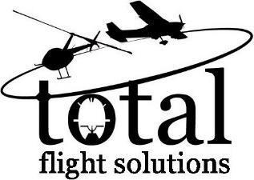
TRANSFER OF CREDIT APPROVAL FORM
Date: ___________
Pilot Name: _________________________________________________
Pilot Certificate Number: _______________________________________
Ratings: ____________________________________________________
Medical Class: ___________ Expiration Date: ___________
Flight time Total time: ________ PIC time: ________________
Solo time: ________
Aircraft make and models flown: _____________________________________
Flight Review Date: ________________ Ground Evaluation Date: __________
Previous Training Accomplished:

Applicant Signature: _______________________________________
Training Accepted:

Chief Flight Instructor Signature: ________________________________

Note: Attach copy of previous training records.
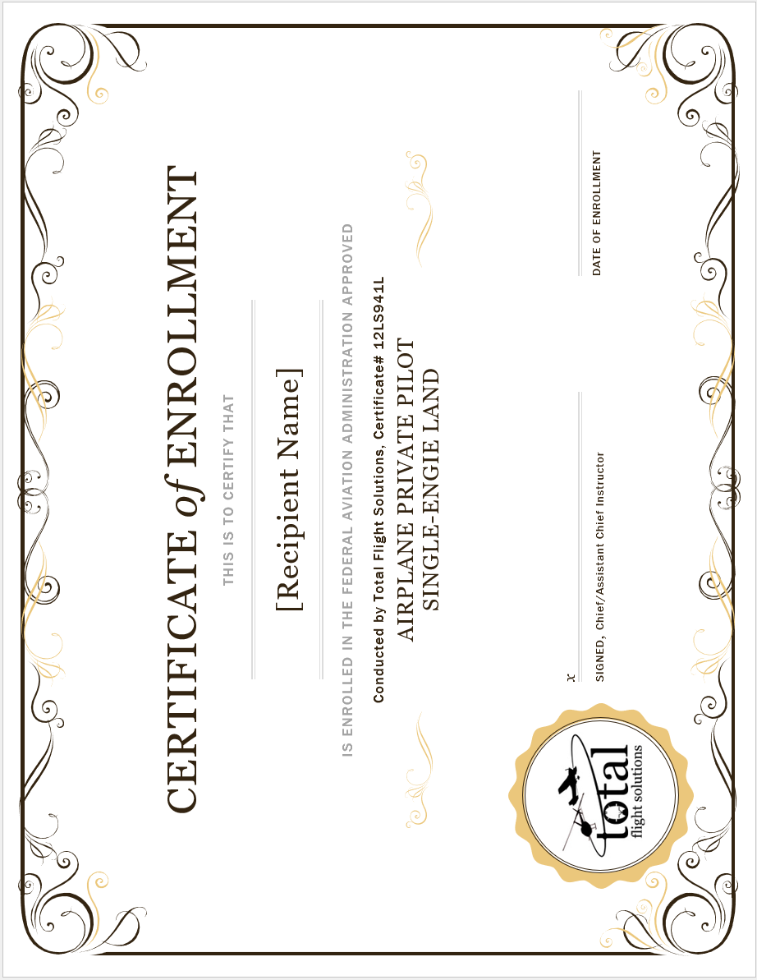

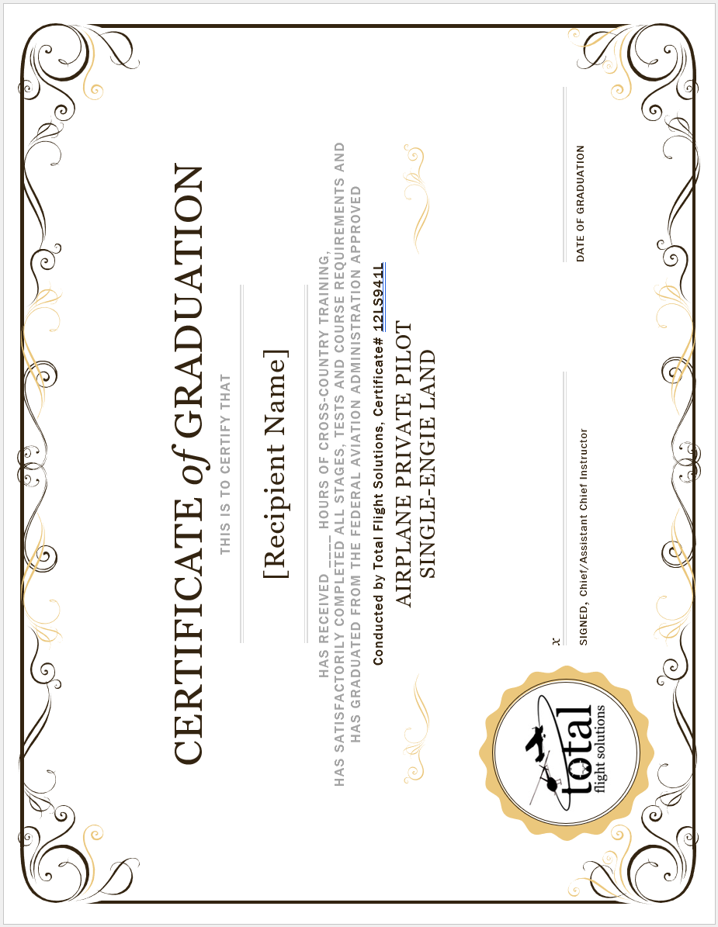
Transfer of Credits

______________________________________________________________________________
(Name of student)
has received the attached list of training from
Total Flight Solutions – FAA Certificate # 12LS941L
In pursuit of his/her
Federal Aviation Administration FAR 141
Airplane Private Pilot Single-Engine Land Certificate.
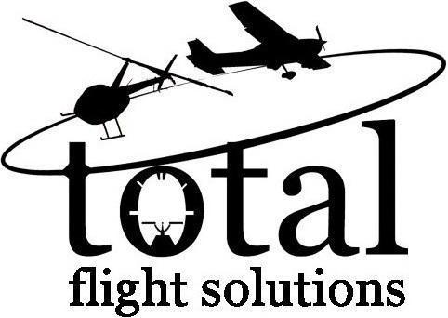

Date of Transfer_____________ Chief/Assistant Chief Instructor _____________________

Termination of Participation in FAR 141
Airplane Private Pilot Single-Engine Land Course

______________________________________________________________________________
(Name of student)
has been removed from the
Federal Aviation Administration
FAR 141 Airplane Private Pilot Single-Engine Land Course.
Conducted by
Total Flight Solutions – FAA CERTIFICATE # 12LS941L

Date of Termination _____________ Chief/Assistant Chief Instructor _____________________

Aircraft Grounded for Maintenance
Maintenance Request Form
Name______________________
Date_ ____________________
A/C N# ____________________
Description of Issue:
______________________________
______________________________
______________________________
______________________________
When it occurred: (i.e. duration)
_____________________________
______________________________
______________________________
Under what conditions: (i.e. maneuvers, normal flight)
______________________________
______________________________

Please return to dispatch to complete the maintenance request.

Aircraft Dispatch Form
This form must be completed and turned into Dispatch
Name: _________________________________
Instructor: _____________________________
Time Out: _________ Time of Return: ______
Route of Flight: _________________________

Did you get a weather briefing? ________
Weight & Balance: Weight ____ lbs. CG: ____
Have you checked the NOTAMS ___________

Verify the following items will not affect your ability to fly
Illness
Medication
Stress
Alcohol
Fatigue
Eating
By signing below, you certify that all above items are
completed and you are prepared for your flight.

Signature: ________________________________

This form must be completed and turned into Dispatch
Training Course Outline
Training Syllabus
Airplane Private Pilot Single-Engine Land Course
This course of training will make use of the Airplane Private Pilot Single-Engine Land Syllabus Books and/or Gleim Online Ground School: Airplane Private Pilot Single-Engine Land (Part 141) course developed by Gleim Publications, Inc. The training syllabus consists of ground and flight lessons that meet the requirements set forth in Appendix B of 14 CFR Part 141.
Enrollment and graduation prerequisites/requirements are detailed in the Introduction of this TCO.
Enrollment and graduation certificates are provided at the end of this TCO. These will be used by Total Flight Solutions, as part of this course of training.
Three copies of this book are included as attachments to this TCO for review and approval as the pilot training syllabus for Total Flight Solutions.
___________________
Tim Grant
Owner

Training Course Outline
Part 141 Student Record Keeping Procedure
Airplane Private Pilot Single-Engine Land Course

In order to satisfy the student record keeping requirement of 14 CFR Part 141.101, we will use the Pilot Training Record created by Gleim Publications, Inc. This booklet meets all the requirements of 14 CFR Part 141.101(a). The lesson sequence contained in this booklet is reflective of the order of lessons contained in the Gleim Pilot Syllabus book on which this course of training is based.
One record will be kept for every enrolled student. These records will be kept on file at Total Flight Solutions Main Base at 450 Airport RD. Suite 200, Louisburg, NC 27549 for a period of at least 1 year from the date the student:
- Graduates from the course to which the record pertains;
- Terminates enrollment in the course to which the record pertains; or
- Transfers to another school.
A copy of the student's training record will be made available upon request by the student.
Three copies of the Gleim Pilot Training Record pertaining to this course of training are included as attachments to this document.

_________________________
Tim Grant
Owner

